CREATE DATABASE company_db;

USE company_db;

CREATE TABLE customers (
customer_id INT AUTO_INCREMENT PRIMARY KEY,
name VARCHAR(100) NOT NULL,
city VARCHAR(50),
age INT
);

CREATE TABLE orders (
order_id INT AUTO_INCREMENT PRIMARY KEY,
customer_id INT,
product VARCHAR(100),
amount DECIMAL(10,2),
order_date DATE,
FOREIGN KEY (customer_id) REFERENCES customers(customer_id)
);

INSERT INTO customers (name, city, age) VALUES
('Alice Johnson', 'New York', 30),
('Bob Smith', 'Los Angeles', 45),
('Charlie Brown', 'New York', 25),
('Diana Prince', 'Chicago', 35),
('Evan Davis', 'Los Angeles', 28);

INSERT INTO orders (customer_id, product, amount, order_date) VALUES
(1, 'Laptop', 1200.00, '2025-01-10'),
(1, 'Mouse', 25.00, '2025-01-12'),
(2, 'Desk', 300.00, '2025-01-15'),
(3, 'Keyboard', 80.00, '2025-01-18'),
(4, 'Monitor', 250.00, '2025-01-20'),
(5, 'Laptop Bag', 60.00, '2025-01-22');

--- where ----

SELECT *
FROM customers
WHERE city = 'New York';

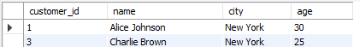

--- AND---

SELECT *
FROM customers
WHERE city = "Los Angeles"
AND age > 28;

---OR---
SELECT *
FROM customers
WHERE city = 'New York'
OR city = 'Los Angeles';
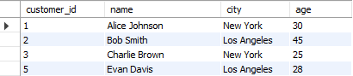

---NOT---
SELECT *
FROM customers
WHERE NOT city = 'Chicago';
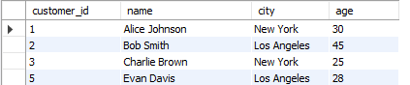

---ORDER BY---
SELECT *
FROM orders
ORDER BY amount DESC;
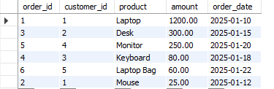

SELECT *
FROM customers
ORDER BY age ASC;

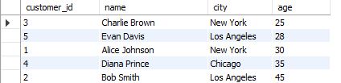

---LIKE---
SELECT *
FROM customers
WHERE name LIKE 'A%';

SELECT *
FROM orders
WHERE product LIKE '%top';

